**PROGRAM-5**

**Insertion sort Algorithm:**

1.j=2

2.while (j<=u)

3.key=A[j]

4. i=j-1

5. while ((i>0) and (A[i] > key)) do

6.A[i+1] = A[i]

7. i = i-1;

8. End while

9. A[i+1] = Key

10. j=j=1;

11. End while

12. STOP

**AIM**-Write an algorithm and program to sort n number using insertion sort technique

**1)Using Arrays-**

#include<iostream>

using namespace std;

int main()

{

int i,j,n,temp,a[20];

cout<<"Enter the no. of numbers to sort:";

cin>>n;

cout<<"\nEnter the numbers:\n";

for(i=0;i<n;i++)

{

cin>>a[i];

}

for(i=1;i<=n-1;i++)

{

temp=a[i];

j=i-1;

while((temp<a[j])&&(j>=0))

{

a[j+1]=a[j];

j=j-1;

}

a[j+1]=temp;

}

cout<<"\nSorted list is as follows\n";

for(i=0;i<n;i++)

{

cout<<a[i]<<" ";

}

return 0;

}

**OUTPUT-**

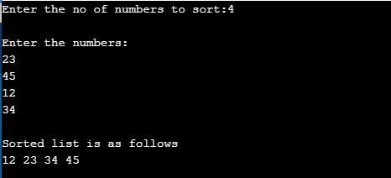

**2) using recursion-**

#include <iostream>

using namespace std;

void insertionSortRecursive(int arr[], int n)

{

if (n <= 1)

return;

insertionSortRecursive( arr, n-1 );

int last = arr[n-1];

int j = n-2;

while (j >= 0 &&arr[j] > last)

{

arr[j+1] = arr[j];

j--;}

arr[j+1] = last;

}

void printArray(int arr[], int n)

{

for (int i=0; i< n; i++)

cout<<arr[i] <<" ";

}

int main()

{

int arr[] = {14,19,3,7,15};

int n = sizeof(arr)/sizeof(arr[0]);

insertionSortRecursive(arr, n);

printArray(arr, n);

return 0;

}

**OUTPUT-**

